Advanced use

Modify the key value table
- Read the scan code of the key you want to modify
In USB receiver mode, click the "Read Scan Code" button (where “stop reading” is now) and press the button to modify. The first 4 bytes displayed are the current scan code, and a total of 4 buttons can be displayed. where fd is no button, and fe is the Fn button. For example, when the A key is pressed, the scan code is 3a.
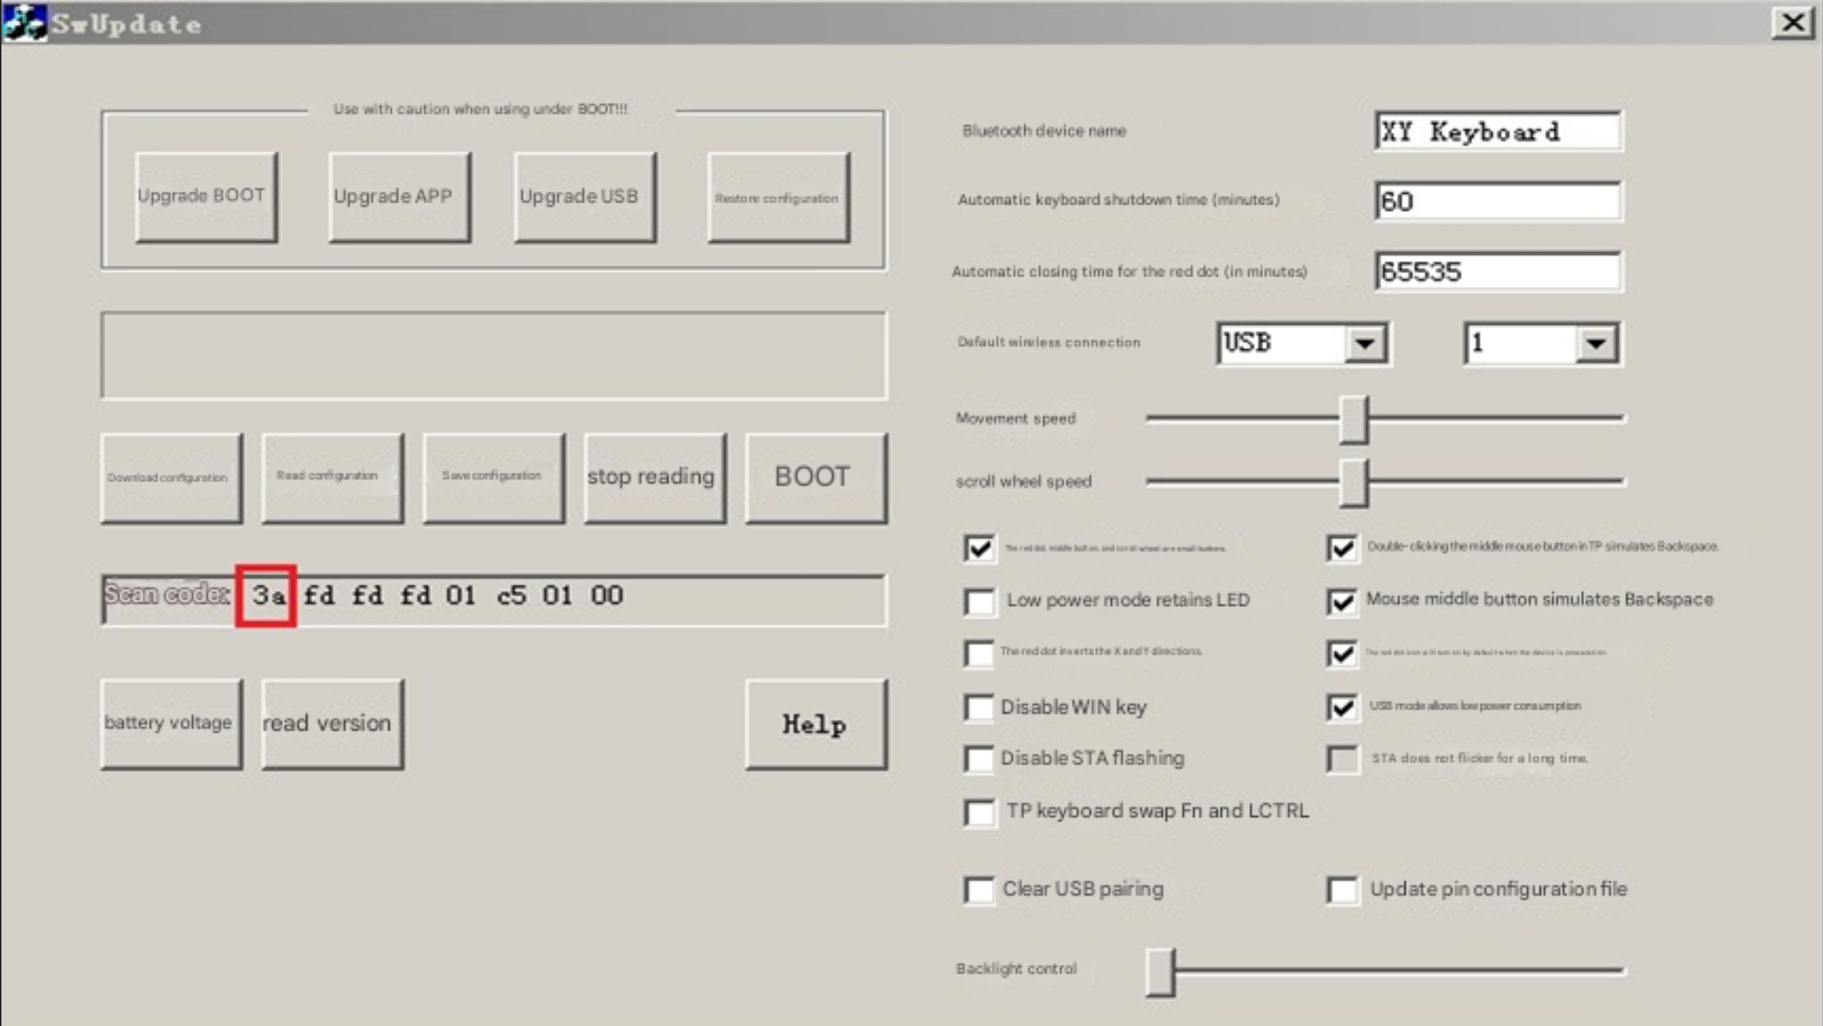
- Modify the key value table
Use the scan code read above to find the position of the key in the key value table and modify it. For example, if the scan code of the A key is 3a, the position of the A key in the key table is row 3, column a, and the key value is 0x0004. There are three types of key values: normal buttons, control buttons, and multimedia buttons. The key value is found from the last three tables of the profile. For a more comprehensive definition of key values, see pages 53 (Normal) and 75 (Multimedia) of the Hut1_12v2.pdf file in Baidu Netdisk. The key value is prefixed according to the key type in the Usage ID column, 0x00 for normal keys, and 0x8 for multimedia keys.
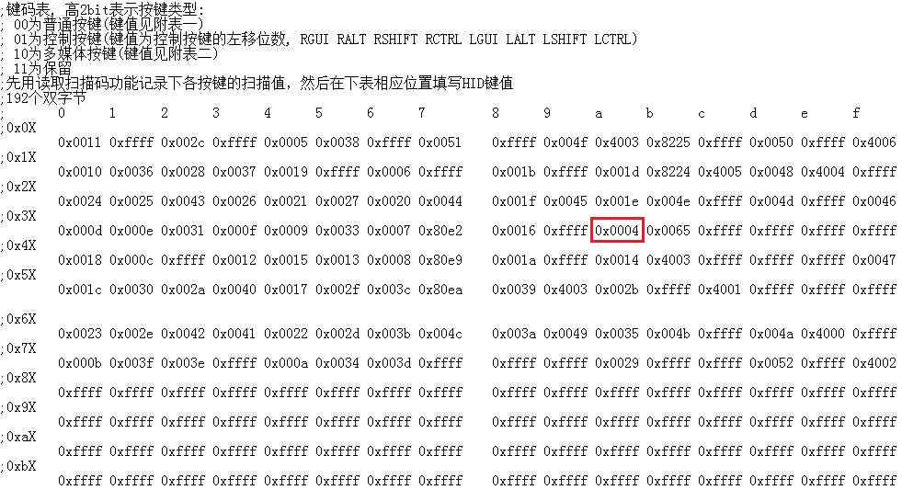
- Download the profile:
Once you've modified all the keys, close and save the profile. Click the "Stop Reading" button, tick the "Update Pin Profile" option, and click the "Download Configuration" button. After downloading the configuration, the keyboard will automatically shut down, and the new configuration will be applied after restarting.
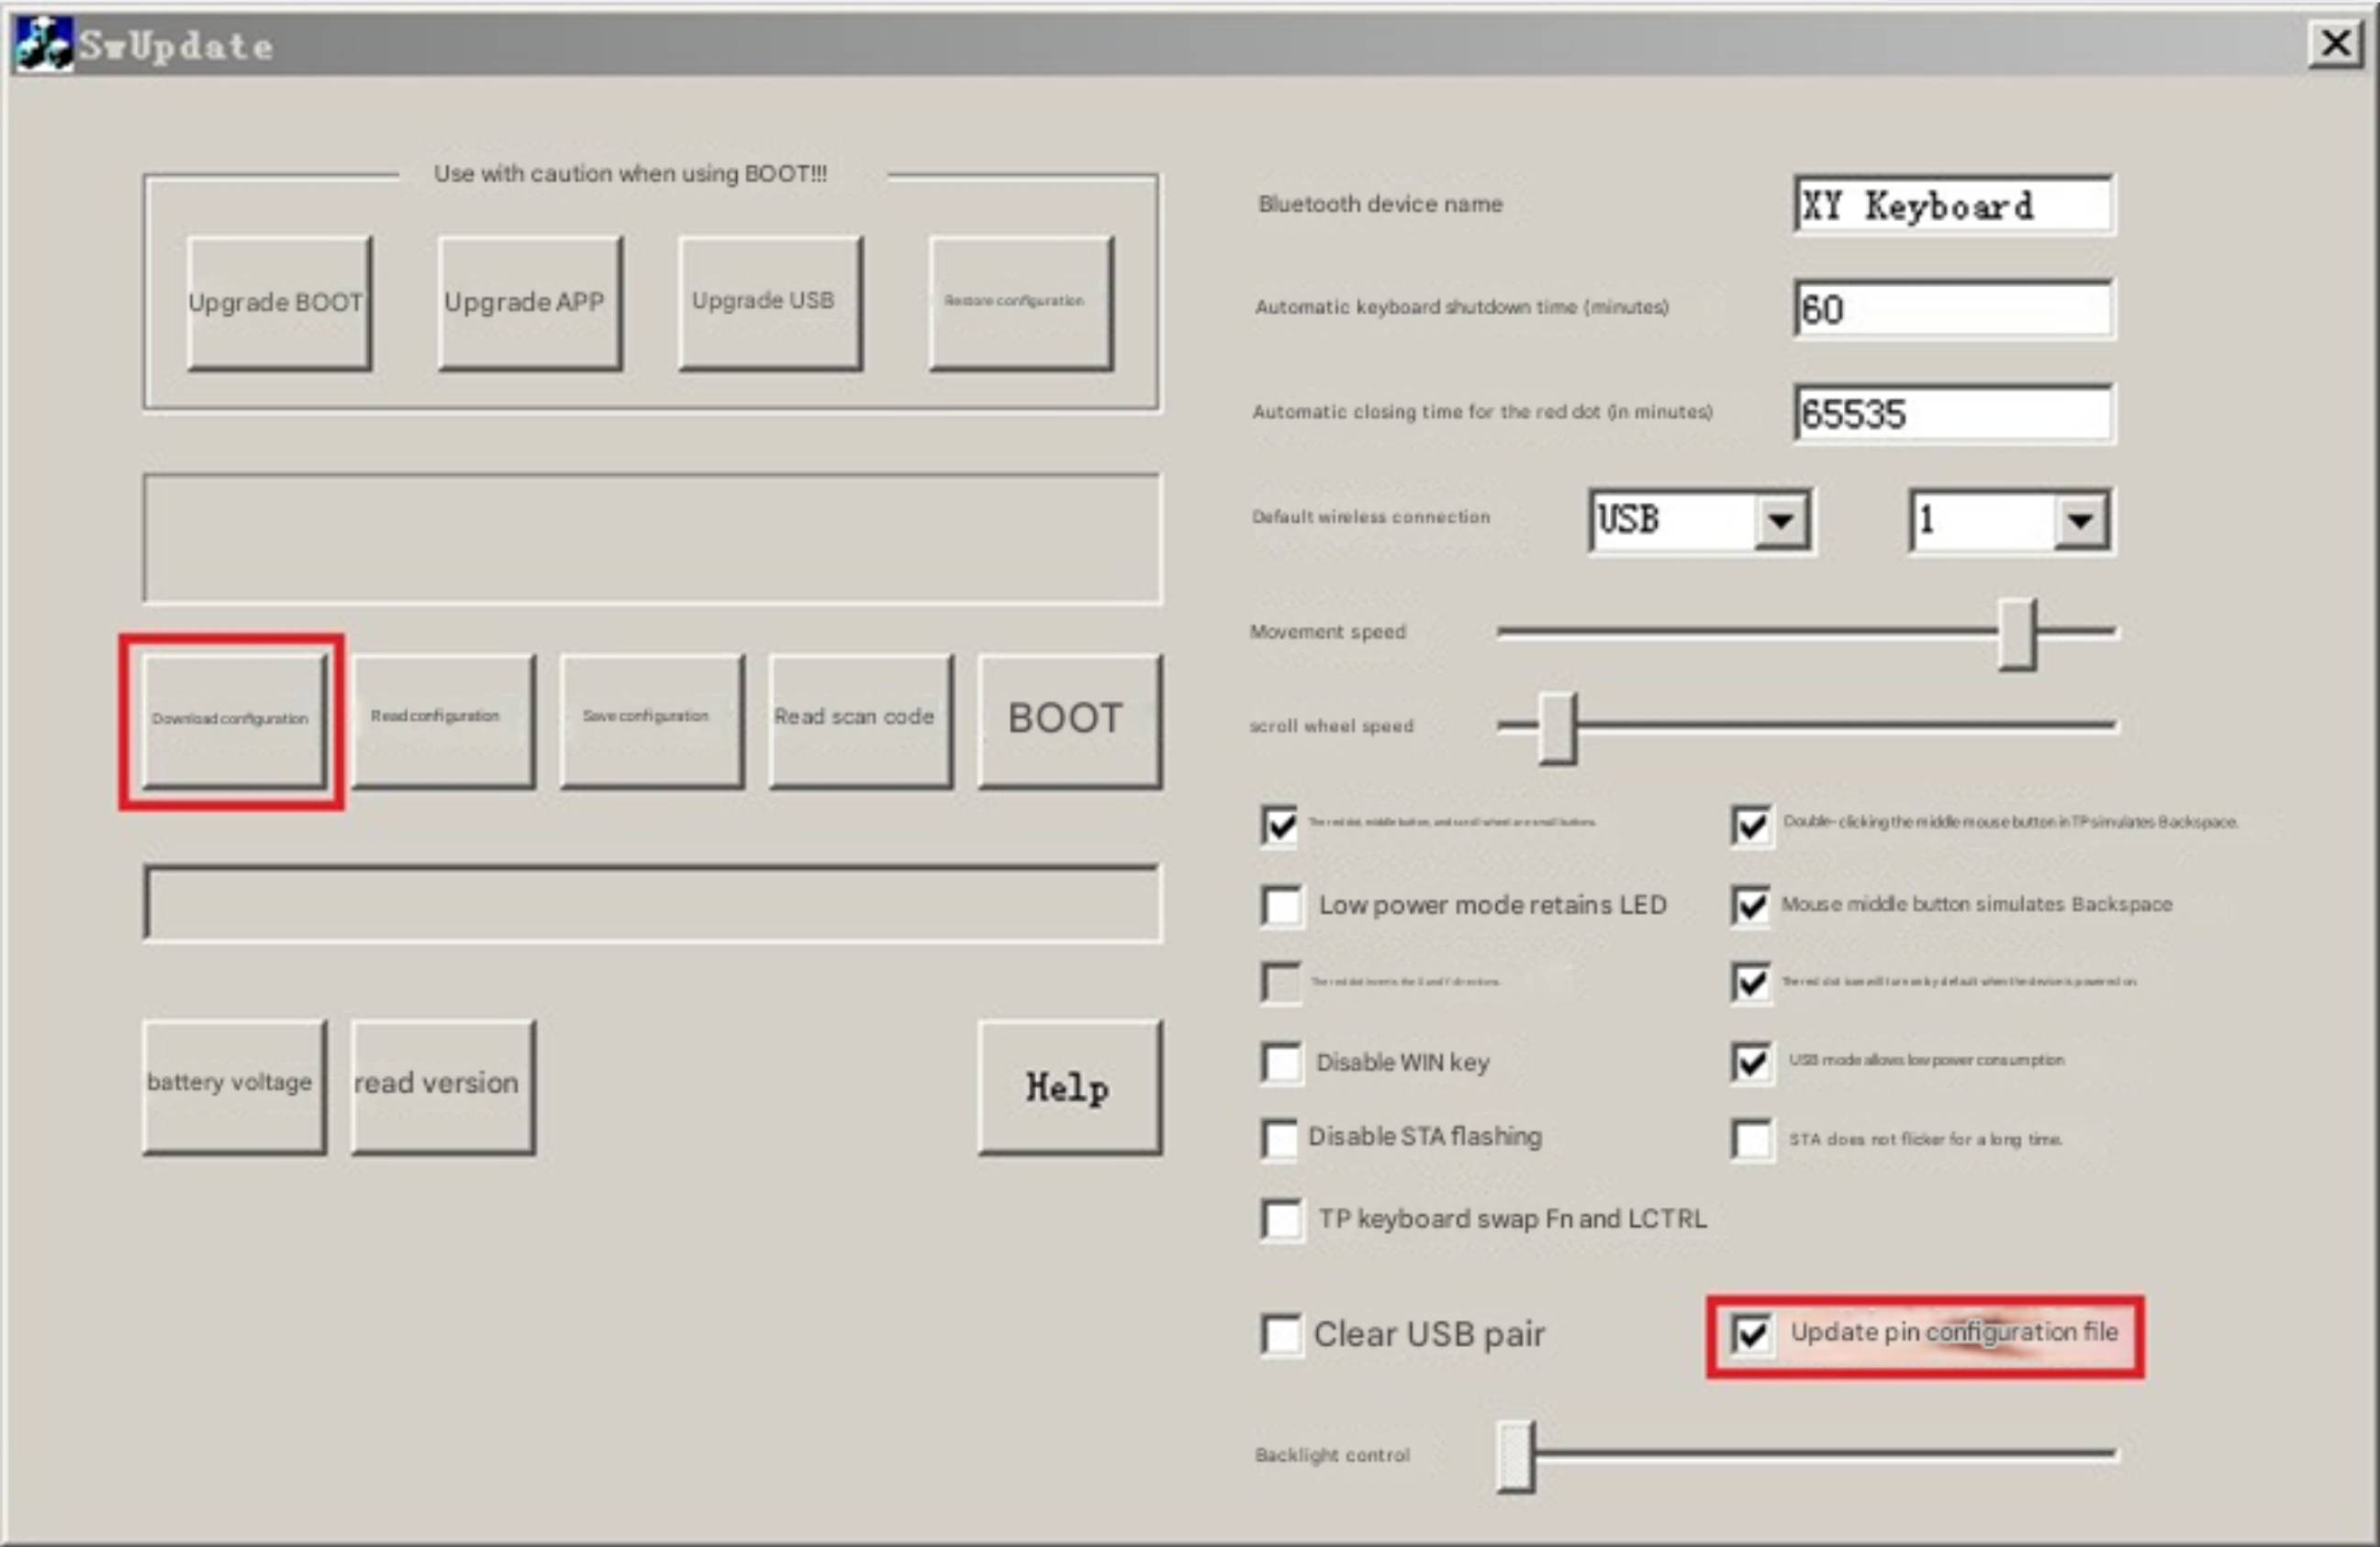

Fn and keypad mapping
The first row of the mapping table scan the code, and the second row maps the key value. For example, if the scan code of the lower arrow is 07, the first line of the scan code is written 0x07, and the second line corresponds to the position key value of the 0x80cd (Play/Pause).
The ThinkPad's keypad function can be understood as Fn mapping with locking, and the mapping table can be changed to other functions. If you don't use the keypad, you can change "0x4f 0xfe" to "0xff 0xff", and the keypad mapping table becomes a supplement to the Fn mapping table above, and a total of 36 Fn mappings can be realized.
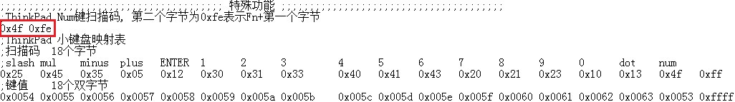

Programmable keys
Programmable keys automatically send a string of predefined keys when a key or combination of keys is pressed. Factory definition: Press the blue key to send "Win+R www.51nb.com Enter" to access the 51nb website.
5 programmable keys can be defined, each containing 4 bytes. The first two bytes are the key scan code, for example, the first line 0x77 blue key 0xfd no key, the second line is Fn+A, and the third line is LCTRL+A (the scan code of the combination button is also read by the read scan code function). The third byte is the starting position of the sent content (the number of lines of the programmable key content). The fourth byte is the length, which is how many lines are sent from the position defined by the third byte.
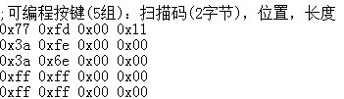
The programmable keypad table has 9 bytes per line:
The first byte is the control button, and each bit represents "RGUI RALT RSHIFT RCTRL LGUI LALT LSHIFT LCTRL pressed".
Byte 2 is fixed to 0x00.
Normal key values for bytes 3-8 (can be found in Table 1, remove the 00 in the middle), e.g. w is a key value of 0x1a.
Byte 9 is the delay after sending this line, in units of 10 milliseconds. The last set of delays is 0, which means that not all keystrokes are sent.
